CIRCULAR MOTION
Topic | KEY UNDERSTANDINGS
Describing Motion | 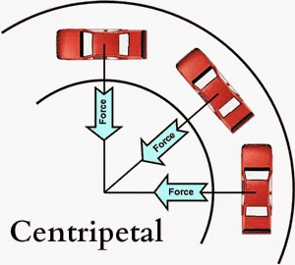  Centripetal is a direction (“center-seeking”), not a type of force.  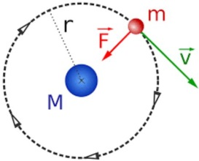  The velocity of an object moving in a circular path is tangential to the path.
Net Force | 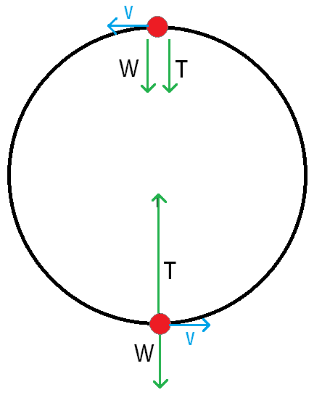  In order for an object to move in a circular path, the net force or a component must be centripetal.
Applications | Circular motion can be only part of a circle!  