Name:_______________________________________ Class:_____________ Date:___________

Activities To Help Students Write Procedures: (Code- Procedures)

Activity #1: Build a Peanut Butter Sandwich

This challenge will require you to write detailed code for a robot to make a peanut butter sandwich. You will need to bring in the necessary supplies to test and finalize your code: a jar of peanut butter, a loaf of bread, a paper plate. The teacher will provide the tool for spreading.

Activity #2: Tie Your Shoes

This challenge will require you to write detailed code to have a robot to tie his/her shoes. You will need to bring in the necessary supplies to test and finalize your code: a pair of shoes with laces that must be tied to secure a foot in place; these shoes should fit the teacher. How will you make sure the teacher’s foot will fit in the shoe?

Activity #3: Obstacle Course

This challenge will require you to write detailed code to direct a blind robot to move from the entrance of the obstacle course to the end of the obstacle course. Your robot will be blindfolded, so you will need to bring in a blindfold. You may use furniture in the room to create your obstacle course, or you may bring in safe
items such as pillows or stuffed animals to add to the obstacle course.

Activity #4: The Juice Box/Pouch Challenge

This challenge will require you to write detailed code to instruct a robot to remove the straw from the juice box and insert it in the appropriate place without spilling a drop of juice. You will need to bring in the necessary supplies to test and finalize your code: juice box or pouch with an attached straw. NOTE: This may take several tries, so you will need to bring in multiple juice boxes/pouches to refine your code.

Setting Up Groups and Getting to Know Each Other!

Lab Group Jobs  Record your job in your lab NOTEBOOK! | Seat # 1 | Seat #2 | Seat # 3 | Seat # 4
 | Materials Manager | Water Manager | Data Manager | Soil Manager
 | 1.) Responsible for inventory of materials and re-stocking bin after lab.  2.) Responsible for making sure all materials are used CAREFULLY AND CORRECTLY  3. Responsible for making sure everyone does their part in clearing up work space | 1.)Responsible for adding the different amounts of water to each plant system  2.) Responsible for making sure water is not wasted. | 1.) Responsible for making sure all group members record the correct data.  2.) Responsible for calculating averages for all data points. | 1.) Responsible for placing the correct amount of soil in each pot.  2.) Responsible for making sure soil is not wasted or thrown on the ground.

1. ___________________ is the materials manager. _________________’s favorite thing about science class is _________________________________________________________________.

2. ___________________ water manager. _________________’s favorite thing about science class is _________________________________________________________________.

3. ___________________ is the data manager. _________________’s favorite thing about science class is _________________________________________________________________.

4. ___________________ is the soil manager. _________________’s favorite thing about science class is _________________________________________________________________.

5. Who is responsible for cleaning up work space? ____________________!

Word Bank
Water manager- administrador de agua carefully -cuidadosamente

Soil manager- administrador de suelo responsible- responsable

Data manager- administrador de datos correctly- correctamente

Materials manager- administrador de materiales thrown- lanzado
Name:________________________________________ Class:_____________ Date:______

What Factors Affect Plant Growth?

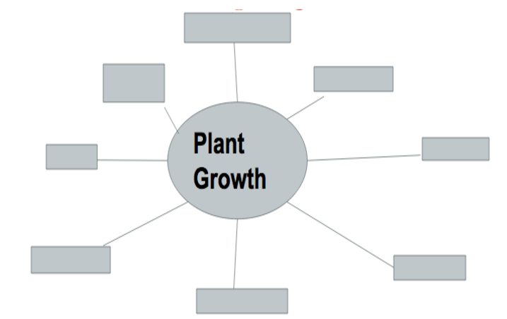

Hints*

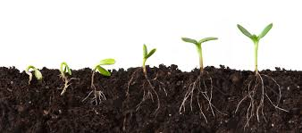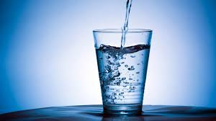

What are we focusing on today? CIRCLE PICTURE, or write it underneath.

Name:________________________________________ Class:_____________ Date:______

Checklist

- Read background research ( How a Seed Grows, Photosynthesis, etc..)

- Answered background research questions

- Formulated scientific question ( What is the Effect of _________ on __________?)

- Identified variables ( Independent variable: I change, manipulated, x axis. Dependent variable: measure, responding variable, usually on the y axis. Constant: Doesn’t change, stays the same.)

- Formulated hypothesis (if…[I.V]...then…[d.v]...because…[se]...)

- Wrote down materials (water, measuring cups, spoons)

- Wrote procedures (step 1, step 2, step 3)

- Completed data table ( How did you collect data? Left side: I.V Top D.V)

- Analyzed data and wrote results (stated data results, NO OPINIONS)

- Conclusion (Was your hypothesis supported? What were your limitations?)

Resources:

Youtube
Vimeo
teachertube
Colorincolorado.org
Readinga-z.com
Edteacher.org
Starfall.com
http://mnliteracy.org/tools/curriculum-lesson-plans/beginning-esl-transitions-skills

